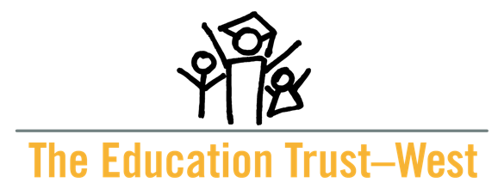

Frequently Asked Questions:
Community of Practice Initiative
Focused on Equitable Course
Placement and Completion at
California Community Colleges

Application Deadline: June 28, 2024

- What is a Community of Practice (CoP)? A facilitated process to learn alongside others who are also engaged in the work of identifying problems and solutions rooted in research-based practices. The equity initiative focused on equitable course placement and completion in mathematics is a cohort-based CoP that will support college teams to improve outcomes for students of color and multilingual learners.
- Why should my campus participate in a community of practice? Selected campuses will work in cohorts and receive peer learning opportunities, technical assistance, and coaching as part of the CoP. Additionally, campus teams will receive support to develop and implement an action plan.
- Who funds the community of practice? The community of practice is funded by the generous support of Ascendium Education Group.
- When is the priority deadline? The priority deadline is May 29, 2024.
- When is the final application deadline? The submission deadline is June 28, 2024.
- How many colleges will be selected for the community of practice? A minimum of 10 and a maximum of 16 California Community Colleges will be selected to join the cohorts.
- How can I learn more about this opportunity? There will be an informational webinar on Wednesday, May 8, 2024, at 11:00 AM. Register in advance for this webinar at: https://edtrust.zoom.us/webinar/register/WN_SDrr8tVXS5-02tdl1Hf1Tw
- How do I apply? Colleges may apply here: https://forms.gle/DvNGFAW9ugpTJ6UdA. The priority application deadline is May 29, 2024.
- When will applicants be notified of a decision? Applicants will be notified in early July 2024 and a public announcement will be made in late July 2024.
- What are the goals for the community of practice? The overall goal of the CoP is to support campus teams to identify practical strategies for adoption of and success in equitable course placement and completion (i.e., changing policies and practices, and changes to course enrollment, completion, and transfer outcomes for students of color and multilingual students) across the California Community Colleges system.
- What are the anticipated outcomes of the community of practice? Campus teams will participate in four sessions from September 2024 through December 2024. Campus teams will commit to:
    - attending each session as a team, including the first in-person session in Oakland, CA on September 23, 2024,
    - completing work in between sessions such as gathering data and/or meeting with key partners,
    - in consultation with colleagues and peers, developing a Blueprint for Equity (i.e., action plan) to implement remediation reform effectively and equitably in mathematics,
    - implementing the plan, and
    - sharing data, outcomes, and reflections in project reports and at two implementation institutes in March and June of 2025.
- Will my campus receive money for my participation in the community of practice? While no direct funding will be provided to colleges to participate, we estimate colleges will receive in-kind technical assistance valued at $75,000. We will cover transportation expenses for the in-person sessions on September 23, 2024, March 12, 2025, and June 4, 2025. Moreover, we highly encourage California community colleges participating in the community of practice to utilize California Community College Equitable Placement and Completion Grant funding under the administration of the Chancellor’s Office. This funding is intended to ensure the implementation of equitable placement and completion policies and practices in California community colleges. Additional, funding sources to implement AB 705 and AB 1705 ​include: Equitable Placement and Completion Grant, Guided Pathways funds, Student Equity and Achievement Funds (SEA), federal minorities serving institutions grants, foundation support, and general funds.
- How will campuses be selected? Colleges will be selected based on their commitment, demonstrated need, and capacity to engage. Priority will be given to teams from colleges serving rural communities and colleges in Los Angeles County.
- Who can I contact with questions? For questions, please email Denise Luna at dluna@edtrustwest.org or Camille Medrano cmedrano@edtrustwest.org.

